Test plan for
<<Codeforces Analyser>>

ChangeLog

Version | Change Date | By | Description
001 | 31.10.23 | Sagar Srivastava | Initial Draft

1 Introduction 2
1.1 Scope 2
1.1.1 In Scope 2
1.1.2 Out of Scope 2
1.2 Quality Objective 2
1.3 Roles and Responsibilities 2
2 Test Methodology 3
2.1 Overview 3
2.2 Test Level……………………………………………………………………………………………………………………………………..3
2.3 Test Completeness 4
3 Test Deliverables 4
4 Resource & Environment Needs 4
4.1 Testing Tools 4
4.2 Test Environment 4
5 Terms/Acronyms 5

1.Introduction
The "Codeforces Analyser" project is a dedicated code repository that offers a streamlined solution for Codeforces online judge users. Leveraging the capabilities of the Codeforces API, this project presents a user-friendly analytics and visualization site. With Codeforces Analyser, users can seamlessly visualize, analyze, and compare Codeforces user profiles, gaining valuable insights into their competitive programming journey.

Some of the standout features of this project include the ability to compare maximum and minimum ratings, track the number of contests in which a user has participated, and identify their highest positive rating achieved. This tool is designed to empower Codeforces enthusiasts, helping them gauge their performance, identify areas for improvement, and benchmark themselves against their peers.

Whether you're a seasoned competitive programmer looking to fine-tune your skills or a newcomer seeking to understand your progress on Codeforces, Codeforces Analyser is the ideal resource for visualizing and comprehending your journey in the competitive coding arena.

Scope

In Scope

Functional Requirement:-
- User registration and authentication.
- Data retrieval from Codeforces API.
- User profile analysis and comparison.
- Contest analysis, including performance and categorization.
- Code analysis for efficiency and style.
- Data visualization using Google Charts.
- Contest reminders and notifications.
Non-Functional requirement:-
- Fast performance and response times.
2.Secure data storage and API calls.
3.Scalability for data volume and user growth.
4.User-friendly and accessible interface.
5.Data accuracy and consistency.
6.Customization and personalization options.
7.Cross-browser compatibility.

Out of Scope

Creating a full-fledged competitive programming platform with features like live contests, user forums, and a problem-setting interface is typically beyond the scope of a Codeforces analyser.

Quality Objective

- Accuracy: Ensure that the data retrieved from Codeforces is accurate and up-to-date to provide users with reliable insights.
- Performance: Achieve fast response times when fetching and analyzing data to enhance the user experience, even during peak usage.
- Security: Implement robust security measures to protect user data, authentication, and API calls to Codeforces.
- Usability: Create a user-friendly interface adhering to Material Design principles to ensure a positive and intuitive user experience.
- Accessibility: Ensure the application follows accessibility guidelines to make it usable for individuals with disabilities.
- Customization: Allow users to customize their experience, such as language preferences or contest selection.

Roles and Responsibilities
Detail description of the Roles and responsibilities of different team members like
- QA Analyst- Priyanshi
- Test Manager- Mr. Abhishek Goyal
- Configuration Manager- Prof. Akankskha
- Developers- Priyanshu Raj, Sagar srivastava
- Installation Team- Priyanshu Raj, Sagar srivastava

Test Methodology

Overview

An Agile methodology is the most suitable for my project. It allows for flexibility, ongoing testing, and adaptation, which are essential for projects that involve machine learning, image processing, and AI. Agile enables you to respond to changing requirements and refine the style transfer algorithm as you gain insights from testing and user feedback.

Test Levels

The testing to be performed is white box testing.
The testing is performed by the developers team along with QA and Configuration Manager.

Unit Testing:
Scope: Individual components and functions of the neural style transfer algorithm.
Objective: To verify that each component works as intended, including layers, loss functions, and optimization steps.
Testing Approach: Developers and machine learning engineers conduct unit tests to validate the correctness of the algorithm at a granular level.

Integration Testing:
Scope: The interactions and interfaces between various components, libraries, and frameworks used in the project.
Objective: To ensure that the integration of different components does not introduce errors or inconsistencies in the style transfer process.
Testing Approach: Developers and testers assess the data flow and interactions between components and detect any integration issues.

Functional Testing:
Scope: The complete neural style transfer system.
Objective: To validate that the system functions according to specified requirements and that it performs accurate style transfers.
Testing Approach: Testers execute functional tests by providing input images and verifying that the output images meet the desired content and style transfer criteria.

Performance Testing:
Scope: Assessing the system's speed and efficiency in handling style transfer tasks.
Objective: To measure how well the system performs in terms of processing time, memory utilization, and resource consumption.
Testing Approach: Performance tests evaluate the system's response time and resource usage under various loads and conditions.

Usability Testing:
Scope: The user interface and user experience.
Objective: To assess how user-friendly and intuitive the interface is for users uploading content and style images.
Testing Approach: Usability tests involve users interacting with the system to evaluate the ease of use, clarity, and navigation of the interface.

Security Testing:
Scope: The system's security mechanisms, especially for handling user data.
Objective: To identify and mitigate potential security vulnerabilities, including data breaches and unauthorized access.
Testing Approach: Security testing includes penetration testing, data encryption checks, and access control assessments.

Compatibility Testing:
Scope: The system's compatibility with various platforms and devices.
Objective: To ensure that the system functions correctly on different browsers, operating systems, and devices.
Testing Approach: Testers verify that the system is compatible with a range of devices and configurations.

Regression Testing:
Scope: The entire system after updates or changes.
Objective: To confirm that new changes or enhancements do not introduce defects or negatively impact existing functionality.
Testing Approach: Automated regression tests are executed to validate that previously tested features still work as expected.

Test Completeness
Here you define the criterias that will deem your testing complete.
For instance, a few criteria to check Test Completeness would be
- 100% test coverage
- All Manual & Automated Test cases executed
- All open bugs are fixed or will be fixed in next release
- All content and style transfer tests have been executed, ensuring that various input images have been processed successfully and meet the defined content and style transfer criteria.
- Automated regression tests have been executed, and previously tested features still work as expected after updates or changes.

Test Deliverables

Test cases:-

Test Case | Test Objective | Test Data | Expected Result |  | Actual Result | Pass/Fail
1 | User Id | User Id | Only Valid User Id |  | Unauthorized  User can  not login | Pass
2 | Content Preservation | Generated images | Content remains recognizable |  | Content recognizable | Pass
3 | Validate content layer | Sample content images, pre-trained model weights | Content layer produces expected feature maps |  | Content layer produces expected feature maps | Pass
4 | Validate style layer | Sample style images, pre-trained model weights | Style layer produces expected Gram matrices |  | Style layer produces expected Gram matrices | Pass
5 | Verify style transfer accuracy | Input images (256x256 pixels) with known content and style | Output images (256x256 pixels) match the desired style and content |  | Output images (256x256 pixels) match the desired style and content | Pass
6 | Verify data security | Testing with simulated security breaches | No unauthorized access or data breaches detected |  | Unauthorized  User can  not access | Pass
7 | Assess the impact of updates | System before and after updates | Previously tested features still work as expected |  | Previously tested features work accurately | Pass

Decision Table for User Login

Conditions | Rule 1 | Rule 2
User Id | False | True
Output(e/h) | error | homepage

Test case Output

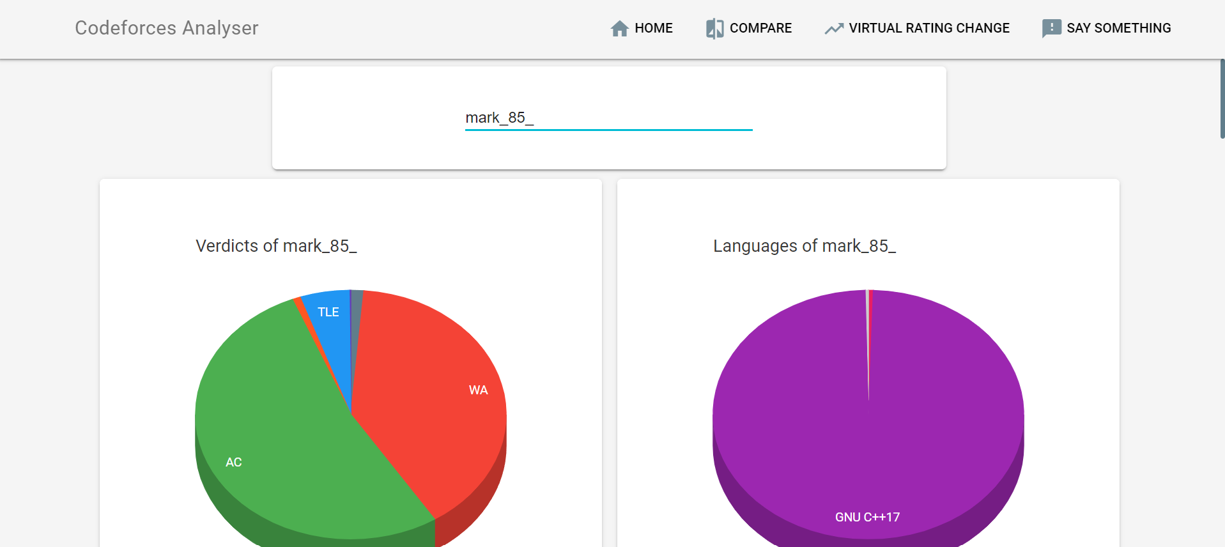

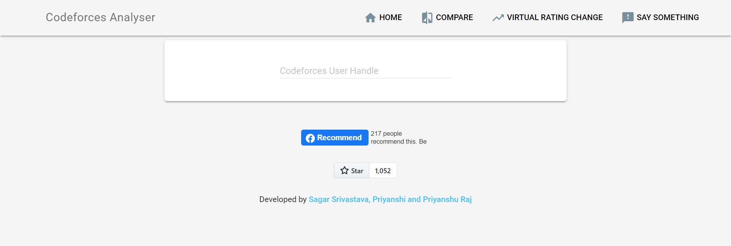

Resource & Environment Needs

Test Environment
It mentions the minimum hardware requirements that will be used to test the Application.

Following software’s are required in addition to client-specific software.

- Windows 8 and above
- Office 2013 and above
- MS Exchange, etc.

Terms/Acronyms
Make a mention of any terms or acronyms used in the project

TERM/ACRONYM | DEFINITION
API | Application Program Interface
DB | Database
UI | User Interface
UX | User Experience

